Lab 1 Pseudocode

1. Wind Chill Temperature

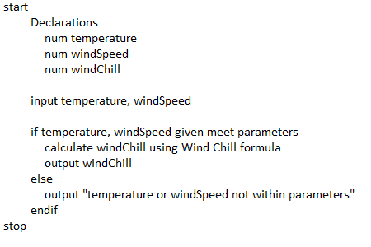

1. Cost of Driving

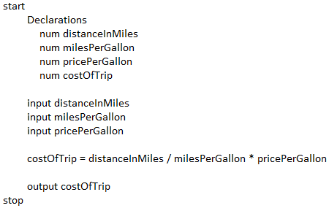

1. Cost of Shipping

